**protected tree marking report for 120km power line from Masa substation to Ngwedi substation near Pilanesberg**

**protected tree marking report – Section 2 (Turfpan – paarl)**

**07 march 2013**



.

Environment Research Consulting (ERC)

PO Box 20640,

Noordbrug,

Potchefstroom

2522

Contact :

A.R. Götze (M.Sc.) Pr.Sci.Nat

Tel : 018 291 1486

Cell: 082 789 4669

Fax:086 621 4843

[albie.erc@gmail.com](mailto:albie.gotze@gmail.com)

Ecosolve Consulting

25 Amari Heights

Kouga Street

Winchester Hills

2091

Contact:

T Lepono

Tel: 011 022 1364

Cell : 083 339 9103

Fax: 086 697 7422

[tsepo@ecosolve.co.za](mailto:tsepo@ecosolve.co.za)

|  |  |
| --- | --- |
| Client: | Senkosi Consulting |
| Report name: | Protected Tree Marking Report - Section 2 (Turfpan - Paarl) |
| Report type: | Protected Trees Marking Report |
| Compiled by: | Tšepo Lepono |
| Qualification: | B.Sc. Hons (Zoology), PGD (Land and Agrarian Science) |
| Affiliation: | IAIA(sa), IoD(SA) – 2010, IWA - 2000, SASAqS - 1999 |
| Fields of Expertise: | Ecological Scientist |

|  |  |
| --- | --- |
| Reviewed by: | A.R. Götze |
| Qualification: | MSc |
| Fields of Expertise: | Ecologist |
| Date | 09 March 2014 |

**II RESERVED COPYRIGHT**

This report has been produced by Ecosolve Consulting (Ecosolve) for Senkosi Consulting (Senkosi). No part of the report may be copied, reproduced or used in any manner without written permission from Senkosi.



Tšepo Lepono

Ecosolve Consultants

**EXECUTIVE SUMMARY**

Ecosolve Consulting (Ecosolve) was appointed by Senkosi to identify and mark protected trees along proposed 1 x 400kV and 1 x 765kV power line corridors between Masa and Ngwedi substations. The assessment covers 120km from farm Rhenosterpan 361 LQ south of Masa Substation to farm Vlakpoort KQ south of Thabazimbi. This report however, covers 40km section from farm Turfpan 54KQ to farm Paarl 124KQ.

In terms of Section 15(1) of the National Forests Act,1998, no person may cut, disturb, damage or destroy any protected tree or possess, collect, remove, transport, export, purchase, sell, donate or in any other manner acquire or dispose of any protected tree or any forest product derived from a protected tree, except under a licence or exemption granted by the Minister to an applicant and subject to such period and conditions as may be stipulated. The objective of this assessment is therefore to identify, georeference and mark all protected trees along the proposed servitude to facilitate application for a licence to clear these trees.

The study area is situated within the Savanna (Bushveld) Biome. The Savanna Biome is the largest Biome in southern Africa, occupying 46% of its area, and over one third of the area of South Africa. It is well developed over the lowveld and Kalahari region of South Africa and is also the dominant vegetation in Botswana, Namibia and Zimbabwe. It is characterized by a grassy ground layer and a distinct upper layer of woody plants. The study area falls within Dwaalboom Thornveld (SVcb1) and Western Sandy Bushveld (SVcb16) vegetation types according to Rutherford, 2006. A national list of protected tree species has been declared to contribute towards the protection of the country's biodiversity and ecosystems as part of South Africa's ratification of the Convention on the Protection of Biological Diversity (CBD). In terms of the declaration, these particular tree species listed as protected may not be cut, disturbed or damaged and their products transported or sold without a license except, which is granted by the Department of Water Affairs and Forestry (or a delegated authority).

Listing certain species as protected is not primarily aimed at preventing the use of a tree species, but to ensure sustainable use through licensing control measures. South Africa is home to more than 1,700 indigenous species of trees and shrubs, some of which are currently threatened on account of their rarity as well as the pressure of commercial and subsistence use. During the field surveys the following protected trees were identified marked and georeferenced:

Table 1: Number of Protected Trees Marked

|  |  |  |
| --- | --- | --- |
| **Scientific Name** | **Common Name** | **Number** |
| *Acacia erioloba* | Camel Thorn | 70 |
| *Boscia albitrunca* | Shepherd’s Tree | 10 |
| *Combretum imberbe* | Leadwood | 252 |
| *Sclerocarya birrea* | Marula | 256 |

A total of 588 protected trees were recorded over the 40km stretch dominated by *C imberbe* (Leadwood) and *S birrea* (Marula).

TABLE OF CONTENTS

1. Introduction 6

2. DESCRIPTION OF THE STUDY AREA 7

3. AIMS AND OBJECTIVES 10

4. Methodology 10

5. RESULTS AND DISCUSSIONS 10

5.1. Dwaalboom Thornveld 11

5.2. Western Sandy Bushveld 11

5.3. Protected Tree Species 12

5.3.1. General Background of Identified Protected Trees 13

6. tree cutting requirements for new power line projects 17

7. Mitigation measures 18

7.1. Vegetation Clearing 18

7.2. Access Roads 20

7.3. Monitoring and Auditing 21

8. Appendix 1: list of Protected Trees 22

9. appendix 2: indigenous trees identified 23

10. Appendix 3: Eskom bush clearing standard 24

1. Introduction

Eskom is expanding transmission and generation infrastructure to ensure that there is sufficient generation capacity to sustain the country’s economic growth. The Waterberg has been identified as potential location of future power generation source. A new power station is being built close to the existing Matimba Power Station, and is to be called the Medupi Power Station.

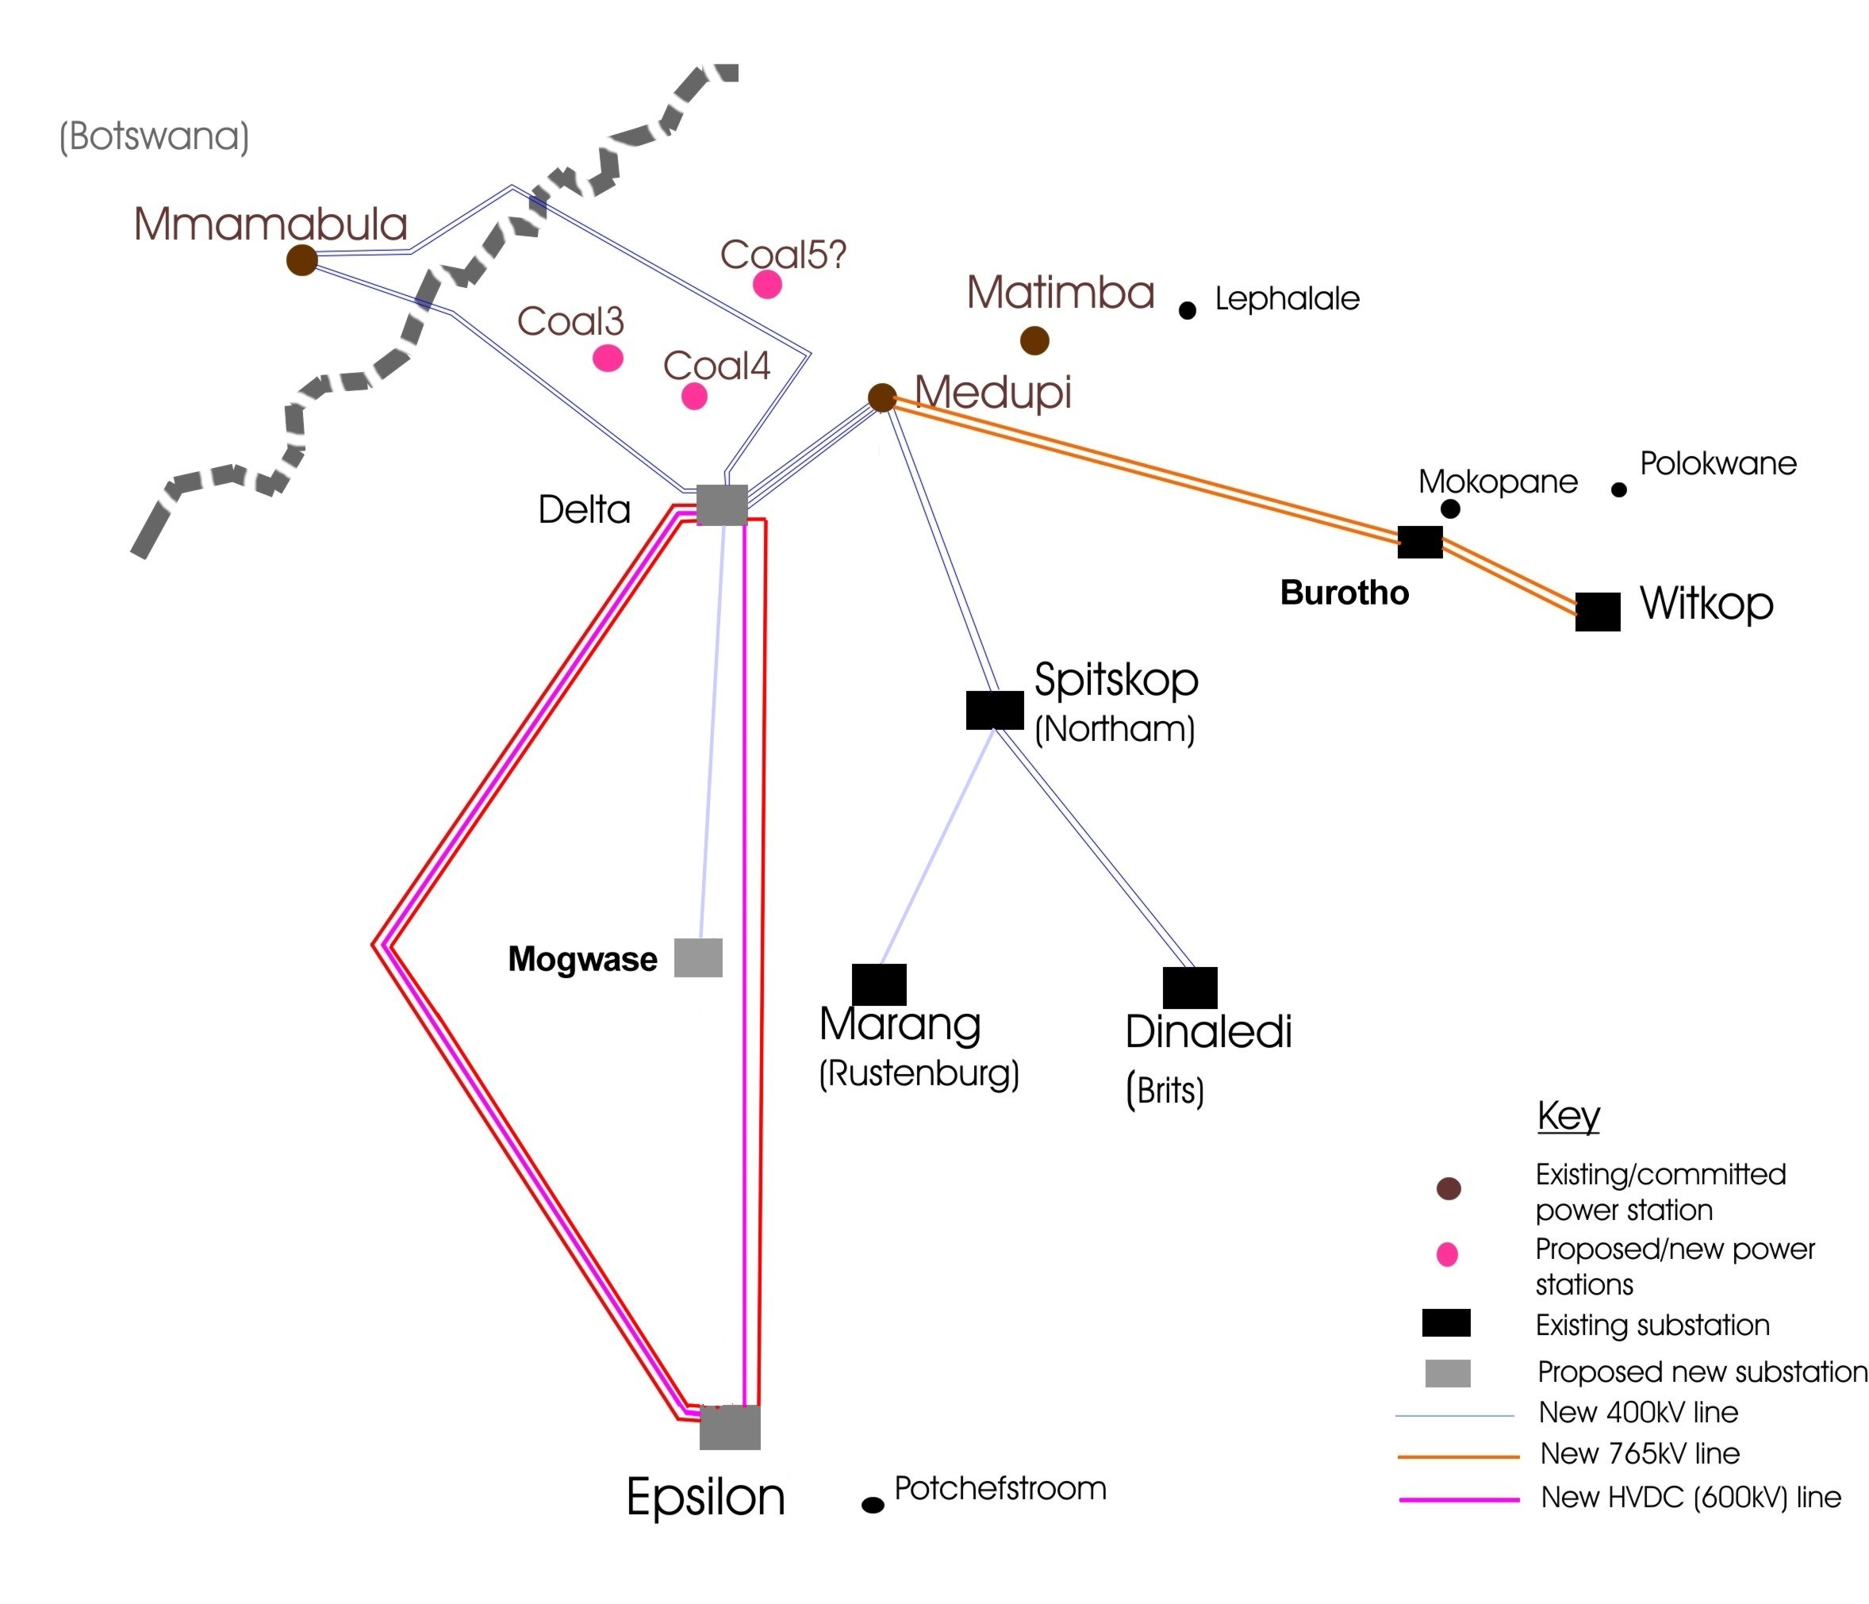

Figure 1: Mmamabula-Medupi Integration Project

In order to transmit the power received from Medupi power station to Eskom’s National Grid, Eskom plans to build six transmission lines from a new substation to be called Masa substation located in the vicinity of Medupi PS to a new substation south west of Potchefstroom to be called Epsilon. The 6th servitude to the east will be used for a 400kV line to the proposed Ngwedi substation in Mogwase, south of Sun City.

Ecosolve Consulting (Ecosolve) was appointed by Senkosi to identify and mark protected trees along proposed 1 x 400kV and 1 x 765kV power line corridors between Masa and Ngwedi substations. The assessment covers 120km from farm Rhenosterpan 361 LQ south of Masa Substation to farm Vlakpoort KQ south of Thabazimbi. This report however, covers 40km section from farm Turfpan 54KQ to farm Paarl 124KQ.

In terms of Section 15(1) of the National Forests Act,1998, no person may cut, disturb, damage or destroy any protected tree or possess, collect, remove, transport, export, purchase, sell, donate or in any other manner acquire or dispose of any protected tree or any forest product derived from a protected tree, except under a licence or exemption granted by the Minister to an applicant and subject to such period and conditions as may be stipulated. The objective of this assessment is therefore to identify, georeference and mark all protected trees along the proposed servitude to facilitate application for a licence to clear these trees.

1. DESCRIPTION OF THE STUDY AREA

The project areas area is situated the Limpopo Province. The 1 x 765kV and 1 x 400kV lines will run between farm Turfpan 54 KQ, approximately 50km north of Thabazimbi and farm Paarl 124KQ about 15km northwest of Thabazimbi. The following farms were assessed:

* Turfpan 54KQ
* Springbokvlei 55KQ
* Ysterpan89KQ
* Blinkwater88KQ
* Krugerspan86KQ
* Franksvlei100KQ
* Rooibokvlei102KQ
* Rietkuil101KQ
* Buffelsvley127KQ
* Paarl124KQ

The study area is largely untransformed while a high degree of transformation is observed around urban areas and within areas where agriculture and urban developments constitute important land use activities. A number of declared conservation areas are situated within the study area.

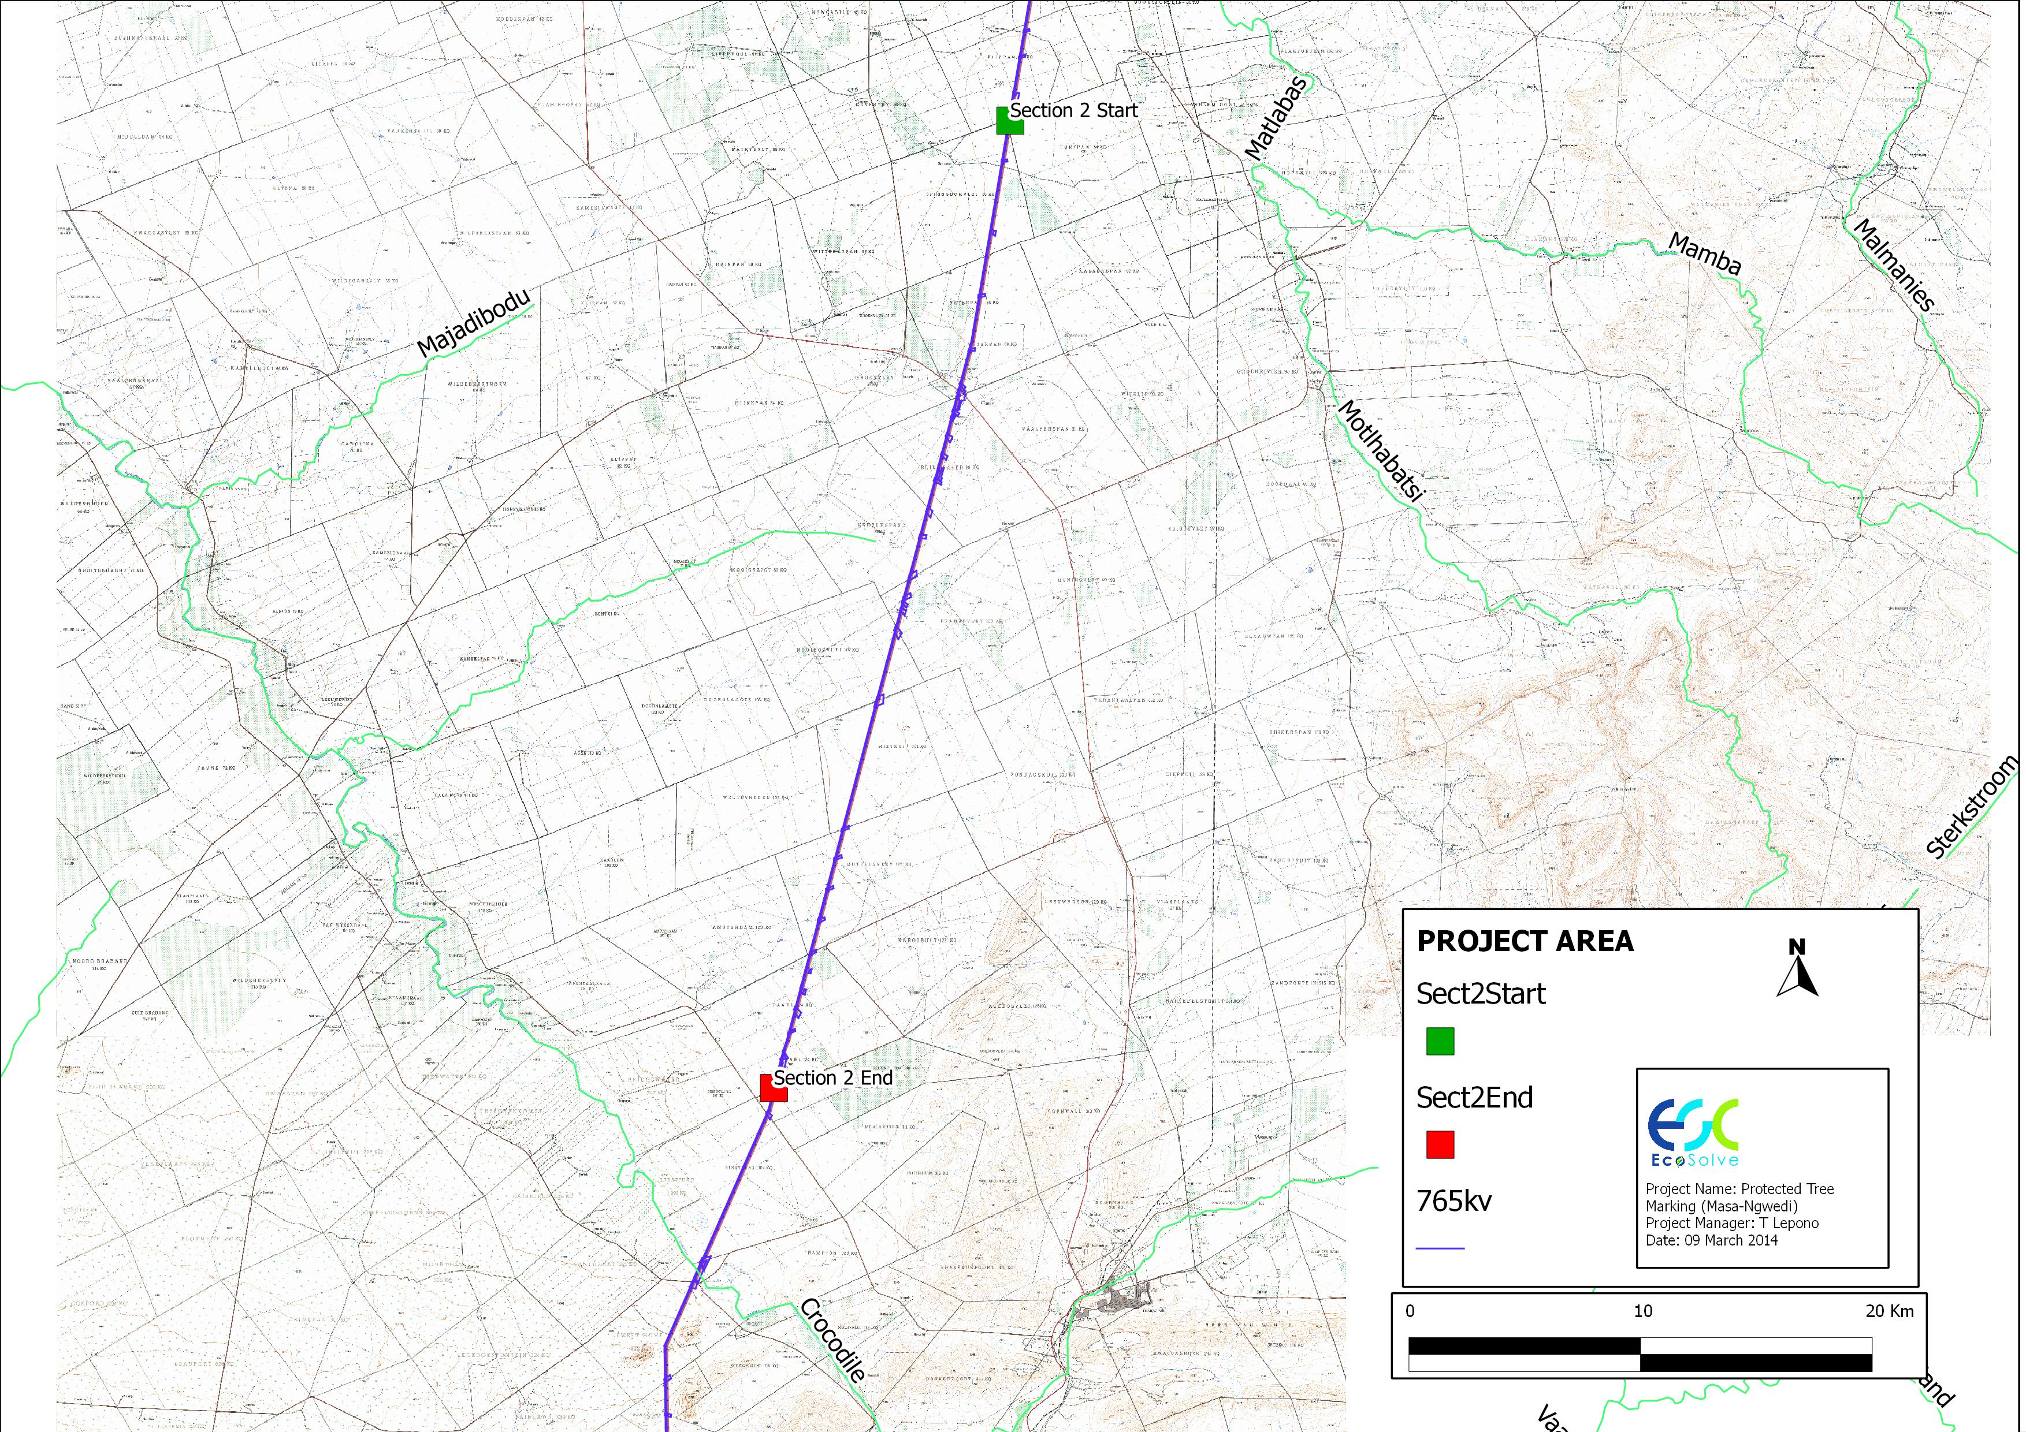

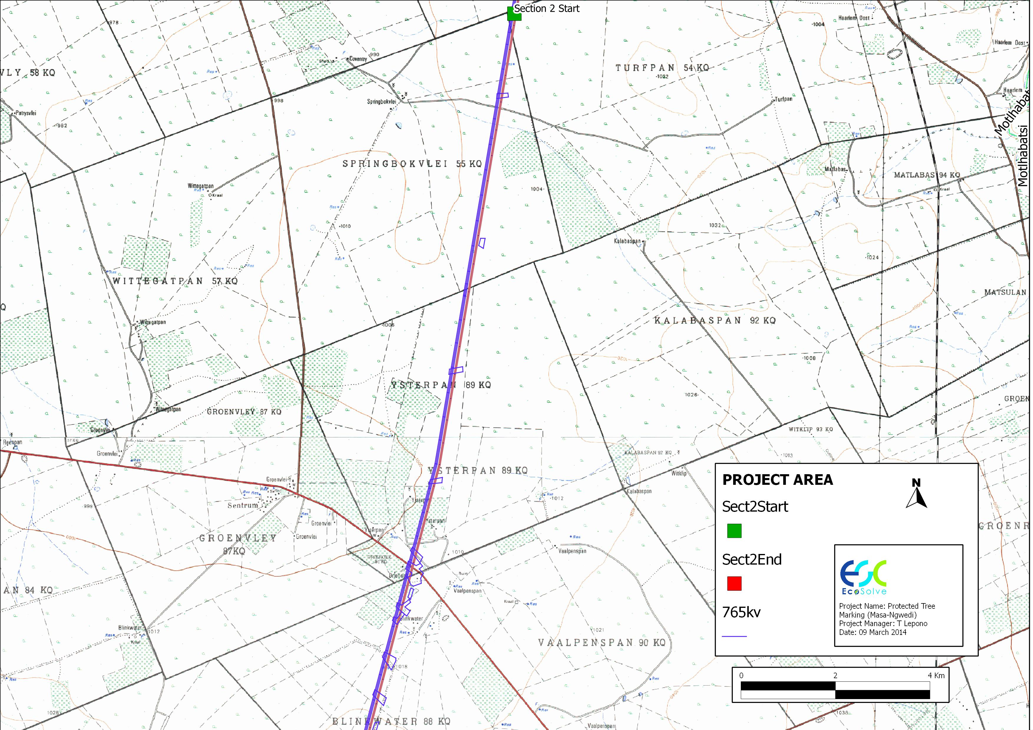

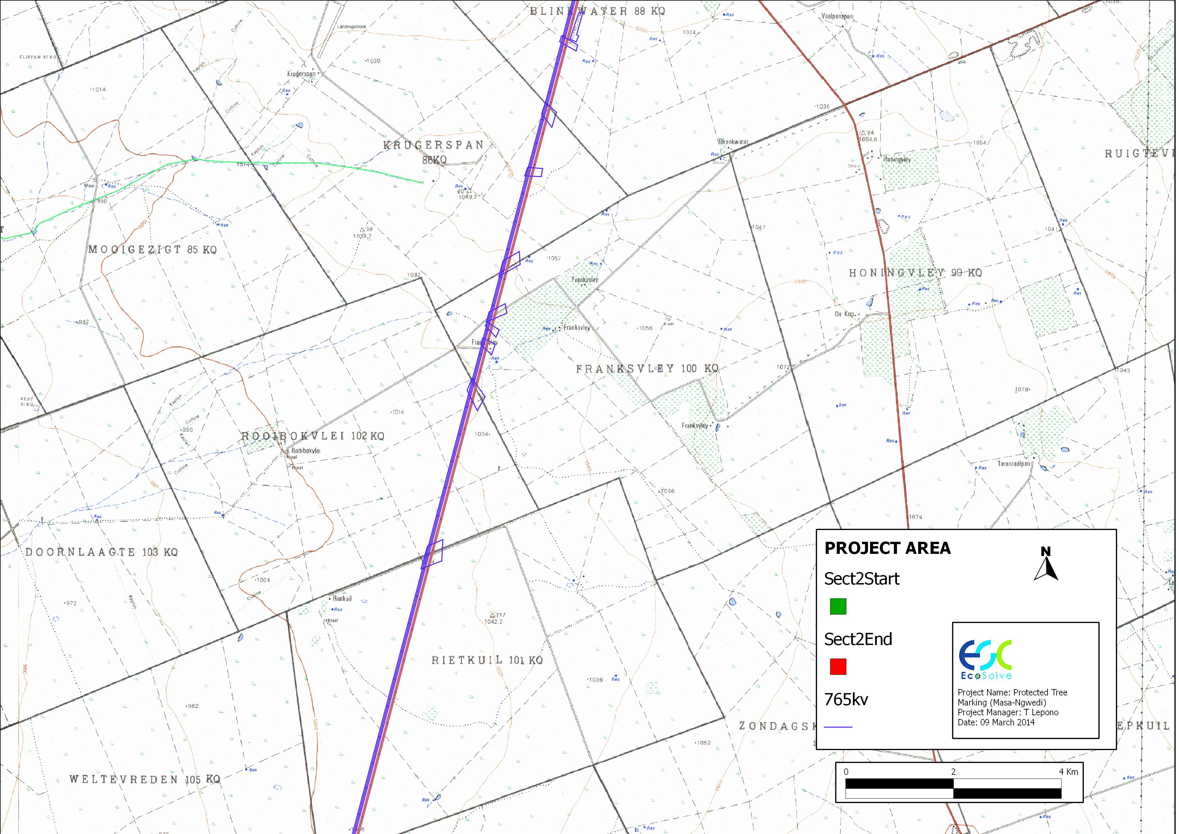

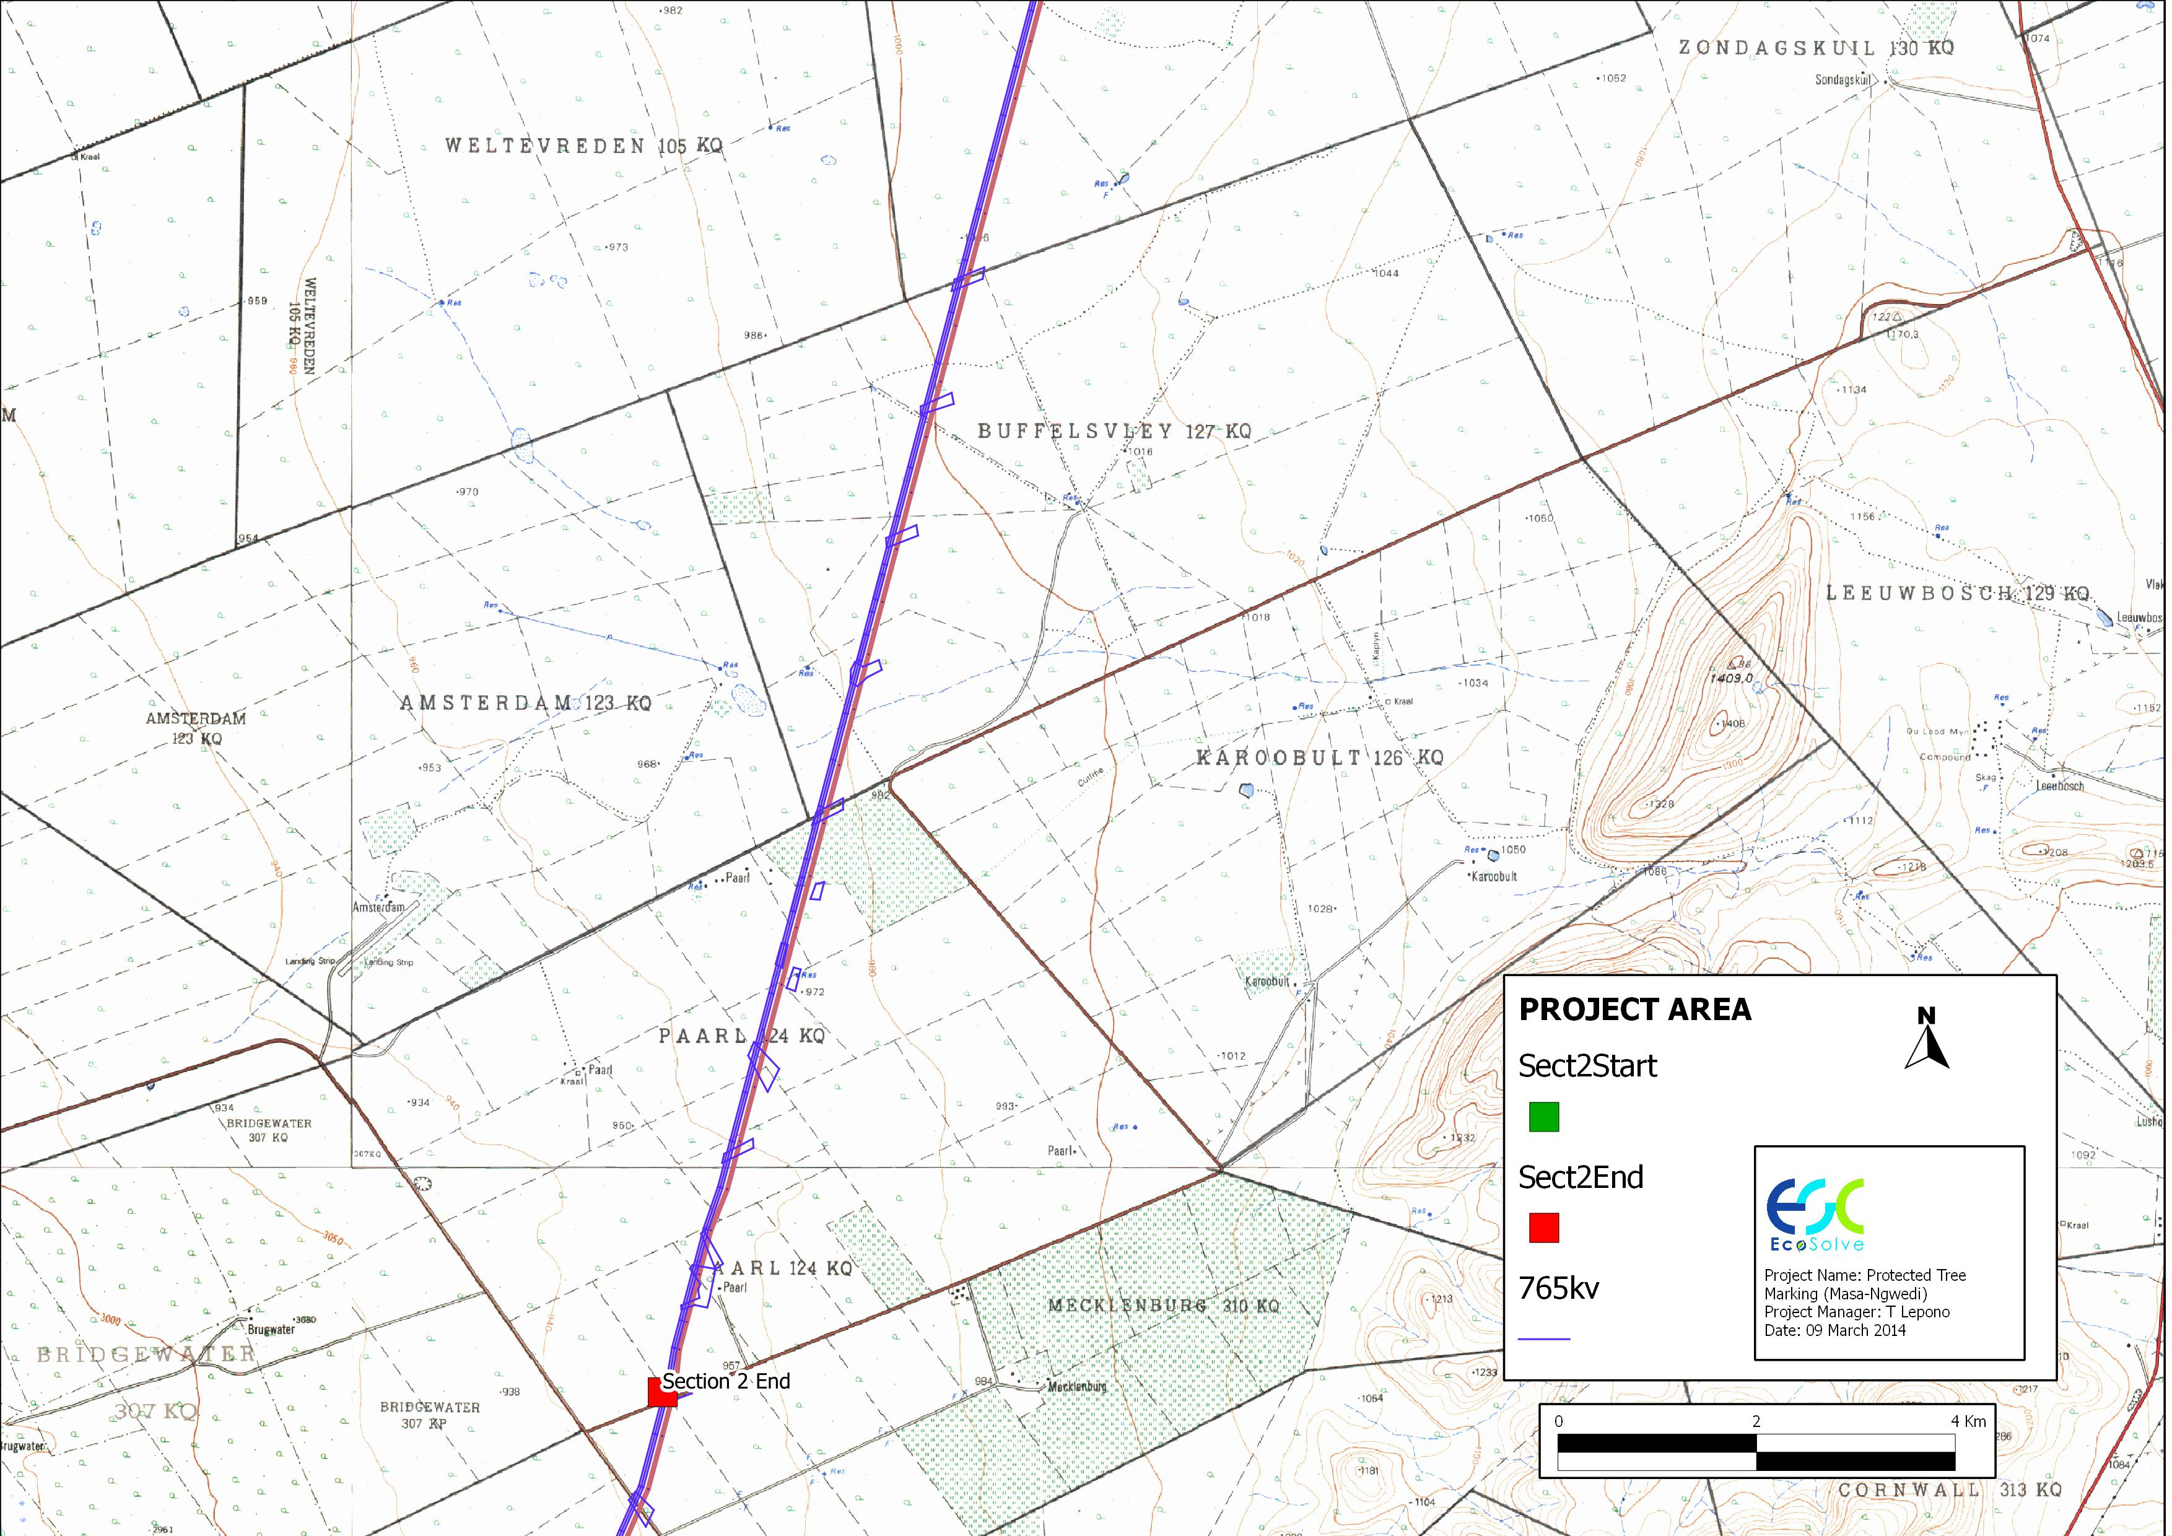

**Figure 2: Map of the Study Area**

1. AIMS AND OBJECTIVES

The objective of power line route bush clearance is to ensure safe installation of the power line and to meet Eskom’s legal, business and environmental obligations and to minimize the risk to affected landowners and the general public. The study therefore ensures that Eskom meets these requirements by:

* Identifying indigenous trees and protected trees of which it is necessary to obtain a permit from the relevant authority in order to cut them as stipulated by National Forest Act, 1998 (Act 84 of 1998). Indigenous trees and bushes that do not grow high enough to cause interference with the power line or cause a fire hazard, shall not be cut down or trimmed.
* Identify any areas that may be considered ‘no-go’ areas and recommend local deviations.
* Recommending measures that should be included in the Environmental Management Plan (EMP) to prevent or limit impacts to protected trees.

1. Methodology

A team consisting of three ecologists walking along the proposed 1 x 400kV and 765kV power lines was deployed to identify, georeference and mark protected trees. For a 400kV powerline, trees were marked within a 30m width from the centre of a proposed powerline. For a 765kV powerline, the distance was 40m. Farm name, species name, number of trees at a particular location as well as X and Y coordinates were recorded. Trees were then sprayed on the stem for identification.

A list of indigenous trees (Appendix 2) was also compiled and the following information recorded:

* Family Name
* Species Name
* Growth Form
* Common Name (English And Afrikaans)
* Conservation Status
* Social Use

1. RESULTS AND DISCUSSIONS

The study area is situated within the Savanna (Bushveld) Biome. The Savanna Biome is the largest Biome in southern Africa, occupying 46% of its area, and over one third of the area of South Africa. It is well developed over the lowveld and Kalahari region of South Africa and is also the dominant vegetation in Botswana, Namibia and Zimbabwe. It is characterized by a grassy ground layer and a distinct upper layer of woody plants. Where this upper layer is near the ground the vegetation may be referred to as Shrubveld, where it is dense as Woodland, and the intermediate stages are locally known as Bushveld. The shrub-tree layer may vary from 1 to 20m in height, but in Bushveld typically varies from 3 to 7m. The shrub-tree element may come to dominate the vegetation in areas which are being overgrazed. Most of the savanna vegetation types are used for grazing, mainly by cattle or game.

The study area falls within Dwaalboom Thornveld (SVcb1) and Western Sandy Bushveld (SVcb16) vegetation types according to Rutherford, 2006.

* 1. Dwaalboom Thornveld

This vegetation type is typical of the vertic clay plains north of the Dwarsberge and associated ridges west of the Crocodile River. It is characterised by plans with layers of scattered, low to medium-high, deciduous microphyllous trees and shrubs with a few broad-leaved tree species, and an almost continuous herbaceous layer dominated by grass species. *Acacia tortilis* and *A. nilotica* dominate on the medium clays (at least 21% clay in the upper soil horizon, but high clay in the lower horizons). On particularly heavy clays (>55%) most other woody plants are excluded and the diminutive *A. tenuispina* dominates at a height of less than 1m above ground. On the sandy clay loam soils (with not more than 35% clay in the upper horizon but high in the lower horizons) *A. erubescens* is the most prominent tree. The alternation of these substrate types creates a mosaic of patches typically 1 – 5km across.

* 1. Western Sandy Bushveld

This vegetation type is typical of the sandy flats and undulating plains west of the Waterberg Mountains. The vegetation structure varies from tall open canopy to low woodland dominated by broad-leaved and microphyllous species on soils underlain by sandstones. Noteworthy species include *Acacia erubescens* on flat areas, *Combretum apiculatum* on shallow soils of gravely upland sites and *Terminalia sericea* on deep sands.

Table 2: Vegetation Types Attributes in the Study Area

|  |  |  |
| --- | --- | --- |
| **Biome** | **Vegetation Type** | **Conservation Status** |
| Savanna | Dwaalboom Thornveld | Least Threatened |
| Savanna | Western Sandy Bushveld | Least Protected |

Figure 3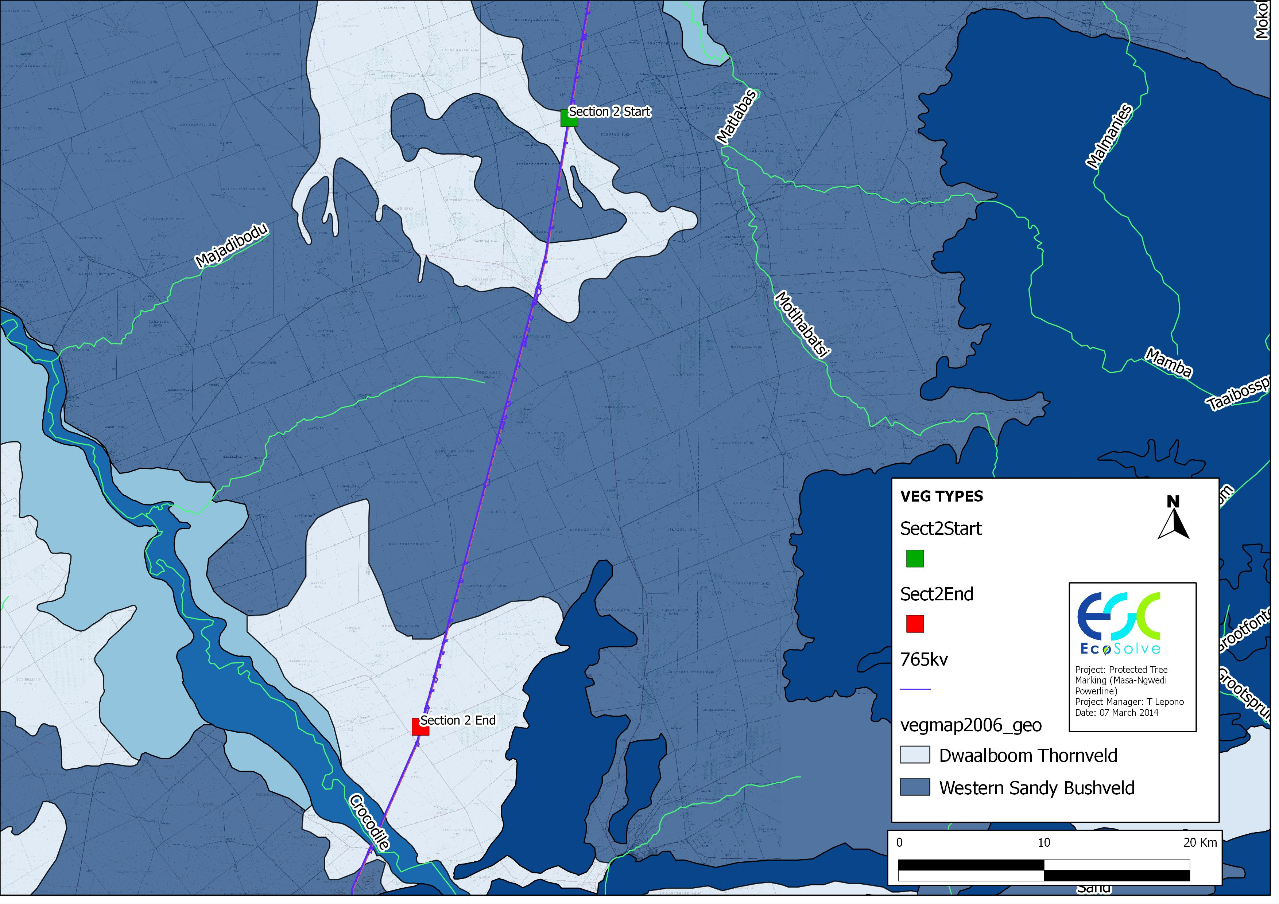: Vegetation Types

* 1. Protected Tree Species

A national list of protected tree species has been declared to contribute towards the protection of the country's biodiversity and ecosystems as part of South Africa's ratification of the Convention on the Protection of Biological Diversity. In terms of the declaration, these particular tree species listed as protected may not be cut, disturbed or damaged and their products transported or sold without a license except, which is granted by the Department of Water Affairs and Forestry (or a delegated authority).

Listing certain species as protected is not primarily aimed at preventing the use of a tree species, but to ensure sustainable use through licensing control measures. South Africa is home to more than 1,700 indigenous species of trees and shrubs, some of which are currently threatened on account of their rarity as well as the pressure of commercial and subsistence use. During the field surveys the following protected trees were identified marked and georeferenced (please refer to Appendix 1 for a list of Protected Trees Identified:

Table 3: Number of Protected Trees Marked

|  |  |  |
| --- | --- | --- |
| **Scientific Name** | **Common Name** | **Number** |
| *Acacia erioloba* | Camel Thorn | 70 |
| *Boscia albitrunca* | Shepherd’s Tree | 10 |
| *Combretum imberbe* | Leadwood | 252 |
| *Sclerocarya birrea* | Marula | 256 |

A total of 588 protected trees were recorded over the 40km stretch dominated by *C imberbe* (Leadwood) and *S birrea* (Marula).

* + 1. General Background of Identified Protected Trees

Scientific name: ***Acacia erioloba***

Family: Fabaceae

Common name: Camel Thorn

Protected status: Protected nationally (DWAF, 2007). Listed as a declining red data species (SANBI, 2009).

Distribution in SA: Northern Cape, Free State, North-West, Gauteng, Mpumalanga & Limpopo Provinces. Widespread in the drier parts of southern Africa.

Uses: The pods are nutritious and eaten by game. Seeds roasted as a coffee substitute. The inner bark is used to produce rope, and the bark is used as a traditional remedy for treating headaches. The gum of the tree is eaten by humans and animals. The wood is popular as firewood.

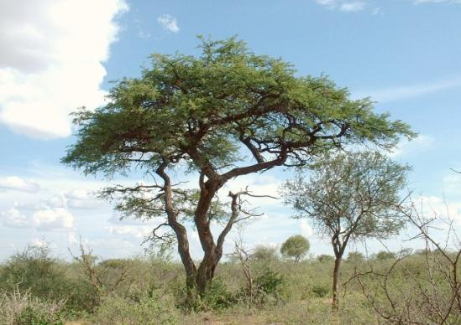

Figure 4: *Acacia erioloba* tree

Scientific name: ***Boscia albitrunca***

Family: Capparaceae

Common name: Shepherd’s Tree

Protected status: Protected nationally (DWAF, 2007).

Distribution in SA: Kwazulu Natal, Northern Cape, Free State, North-West, Gauteng, Mpumalanga & Limpopo Provinces. Widespread in the drier parts of southern Africa.

Uses: Important fodder tree, browsed extensively by game and livestock. Roots are dried and roasted and used as a substitute for coffee or chicory, or ground into a white meal for the making of a nutritious porridge. Trees are believed to have magical properties and are used medicinally. Larval food plant of the Pieridae butterfly family.

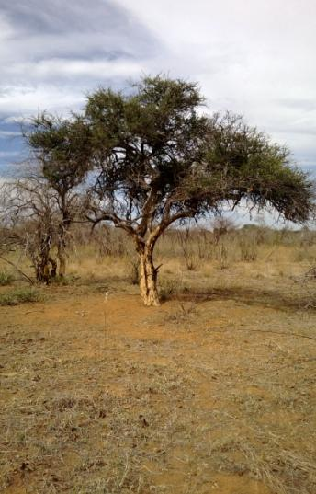

Figure 5: *Boscia albitrunca* tree

Scientific name: ***Combretum imberbe***

Family: Combretaceae

Common name: Leadwood

Protected status: Protected nationally (DWAF, 2007).

Distribution in SA: Northern Kwazulu Natal, North-West, Gauteng, Mpumalanga & Limpopo Provinces.

Uses: Popular as firewood and for carving in the making of utensils and curios. Used for fence posts and in the past as railway sleepers and mine props. Ash from burned wood is rich in lime and is used as toothpaste and whitewash. Leaves browsed by game.

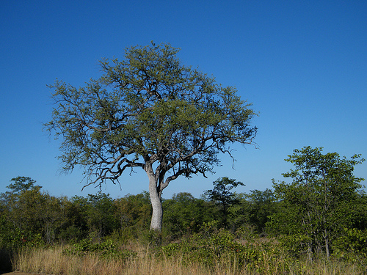Figure 6: *Combretum imberbe* tree

Scientific name: ***Sclerocarya birrea* subsp*. caffra***

Family: Anacardiaceae

Common name: Marula

Protected status: Protected nationally (DWAF, 2007).

Distribution in SA: Kwazulu Natal, Mpumalanga & Limpopo Provinces.

Uses: The fruit is a valuable food source for both humans and animals. Seeds (nuts) are used raw, cooked or ground. The fruit is used to make a jelly preserve and also fermented to make an intoxicating drink.

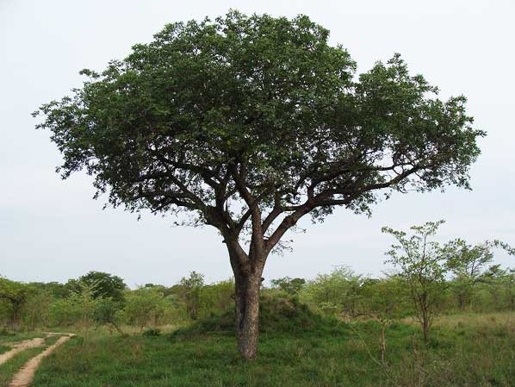Figure 7: ***Sclerocarya birrea subsp. caffra***

1. tree cutting requirements for new power line projects

The following table is extracted from Eskom’s Standard for Bush Clearance and Maintenance within Overhead Powerline Servitudes, 2000 Reference Number ESKASABG3 (Appendix 3). This standard shall serve as a guiding document for bush clearing on the Masa – Ngwedi 400kV and 765kV Powerline Project.

Table 4: The Minimum Standards to be used for Bush Clearing for New Powerline Construction (Eskom, 2000)

| **Item** | **Standard** | **Follow up** |
| --- | --- | --- |
| Centre line of proposed powerline | Clear to a maximum (depending on the tower type and voltage) of an 8m wide strip of all unwanted vegetation along the centre line. Vegetation to be cut within 100mm of the ground. Treat stumps with herbicide. | Re-growth shall be cut within 100mm of the ground and treated with herbicide as necessary. |
| Inaccessible valleys (trace line) | Clear a 1 m strip for access by foot only for the pulling of a pilot wire by hand. | Vegetation not to be disturbed after initial clearing – vegetation to regrow. |
| Access road | Clear a maximum (depending on the tower type and voltage) 5 m wide strip for vehicle access within the maximum 8m width, including de-stumping/cutting stumps to ground level, treating with a herbicide and re-compaction of soil. | Re-growth to be cut at ground level and treated with herbicide as necessary. |
| Proposed tower position and Proposed support/stay wire position | Clear all vegetation within proposed tower position and within a maximum (depending on the tower type and voltage) radius of 5 m around the position, including de-stumping/cutting stumps to ground level, treating with a herbicide and re-compaction of soil. | Re-growth to be cut at ground level and treated with herbicide as necessary. |
| Indigenous vegetation within servitude area (outside of the maximum 8 m strip) | Area outside of the maximum 8m strip and within the servitude area, selective trimming or cutting down of those identified plants posing a threat to the integrity of the proposed powerline. | Selective trimming |
| Alien species within servitude area (outside of the maximum 8 m strip) | Area outside of the maximum 8m strip and within the servitude area, cut all vegetation within servitude area and treat with appropriate herbicide. | Cut and treat with appropriate herbicide. |

1. Mitigation measures
   1. Vegetation Clearing

* Obtain necessary and required approval per application for damage/ removal/ cutting/ pruning of Protected tree species from Department of Agriculture, Forestry and Fisheries (DAFF) , as per National Forests Act (Act No. 84 of 1998) under Government Notice GN 1012 of 2004 and GN 767 of 2005;
* Information pertaining to these plants should be included in the induction for all workers and contractors;
* Disturbance of vegetation must be limited to areas of construction;
* Cut vegetation (grass and shrubs) only if required. No clearing of vegetation or soil by grading machinery shall be undertaken;
* Use of branches of trees and shrubs for fire making purposes is strictly prohibited;
* All trees and vegetation cleared from the site shall be cut into manageable lengths and neatly stacked at regular intervals along the line;
* No vegetation shall be pushed into heaps or left lying all over the servitude;
* The establishment and regrowth of alien vegetation must be controlled after the removal of grass;
* All declared aliens must be identified and managed in accordance with the Conservation of Agricultural Resources Act, 1983 (Act No. 43 of 1983), namely:
* Treatment with a weed killer that is registered for use in connection with such plants in accordance with the directions for the use of such a weed killer;
* Any other method or strategy that may be applicable and that is specified by the executive officer by means of a directive.
  + According to the Conservation of Agricultural Resource Act (No. 43 of 1983) as amended, the person applying herbicide must be adequately qualified and certified as well as registered with the appropriate authority to apply herbicides.
  + Exposed areas with slopes less than 1:3 should be rehabilitated with a grass mix that blends in with the surrounding vegetation. The grass mix should consist of indigenous grasses adapted to the local environmental conditions;
  + The revegetated areas should be temporarily fenced to prevent damage by grazing animals;
  + Re-vegetated areas showing inadequate surface coverage (less than 30 % within eight months after re-vegetation) should be prepared and re-vegetated from scratch;
  + Damage to re-vegetated areas should be repaired promptly;
  + Exotic weeds and invaders that might establish on the re-vegetated areas should be controlled to allow the grasses to properly establish;
  + Weed control methods should be confirmed with the ECO to prevent any undesirable secondary impacts;
  + Monitoring the potential spread of declared weeds and invasive alien vegetation to neighbouring land and protecting the agricultural resources and soil conservation works are regulated by the Conservation of Agricultural Resources Act, No. 43 of 1983 and should be addressed on a continual basis;
  + Re-vegetated areas should be monitored every four months for the first 12 months and once a year thereafter for the maintenance period of two years; and
  + Remove invasive and alien vegetation. The implementation of a monitoring programme in this regard is recommended, being the responsibility of the ECO/ ecologist;
  1. Access Roads
* Minimise damage to embankments.
* Minimise erosion of embankments
* Vehicle access to the power line servitude must be limited to existing roads
* A physical access plan along the servitude shall be compiled and the Contractor shall adhere to this plan at all times.
* Proper planning when the physical access plan is drawn up by the ECO in conjunction with the Contractor shall be necessary to ensure access to all tower sites.
* New access roads will be subjected to a separate assessment including inspection and reporting by qualified botanist.
* All access roads will be marked
* Agreed on Access to be used at all times.
* No illegal use of private roads during construction due to damage anticipated as a result of heavy vehicles and equipment
* All existing private access roads used for construction purposes, shall be maintained at all times to ensure that the local people have free access to and from their properties.
* Speed limits shall be enforced in such areas and all drivers shall be sensitised to this effect.
* Upon completion of the project all roads shall be repaired to their original state.
* No roads shall be cut through river- and stream banks as this may lead to erosion causing siltation of streams and downstream dams.
* No scalping shall be allowed on any part of the servitude road unless absolutely necessary.
  1. Monitoring and Auditing
* A monitoring programme shall be put in place in order to ensure compliance to the EMP, but also to monitor environmental issues and impacts.
* The requirements for an audit shall be stipulated in the contract or work instruction. An audit shall be undertaken within the specified period, but must be undertaken before the contract is signed off. The audit shall be used to identify any non-conformances, for which corrective action is necessary. Corrective action shall take place before the contract is signed off.
* The duration of the project should be taken into consideration when budgeting and planning for monitoring activities. Monitoring should be carried out every month.
* Critical periods during which significant environmental impact could occur are to be identified, and the presence of the Eskom representative (who will co-ordinate with the ECO) during those periods to avoid unwanted impacts is essential.
* An audit shall be undertaken during bush clearing as well as within a specified period after completion of the work but before the contract is signed off. The audit shall be used to identify non-conformance for which the Contractor shall take corrective action. The auditor may either be internal or external to Eskom.
* The contractor shall arrange an inspection with the project manager, who will inform the ECO, for the final inspection of the works. A first inspection will be done on which Eskom will draw up a snag list. Should the same items on the snag list still not be according to Eskom’s satisfaction on the second inspection, all direct costs incurred for re-inspection will be on the contractor’s account.

1. Appendix 1: list of Protected Trees
2. appendix 2: indigenous trees identified
3. Appendix 3: Eskom bush clearing standard

Refer to Appendix 3.2 Eskom standrds